**BACHKHOA-APTECH**

**GRADUATION PROTECTION PROJECTS SEM III**

**------------------------------------------------------------**

**NEXUS SERVICE MARKETING SYSTEM**

**Student: Nguyễn Văn Tiến**

**Code: Student1096534**

**Tools, Program languages and frameworks**

## Tools.

### Visual Studio

### SQL Server Studio

### Visual Studio Code

## Program languages and frameworks

### .NET MVC, HTML5, CSS3, JAVASCRIPT

### Entity Framework, Code First

**PREFACE**

Today, the application of information technology and computerization is considered as one of the decisive factors in the operations of governments, organizations, as well as companies, it plays a very important role. Importantly, can create powerful breakthroughs. By the internet, we can get things done at a much faster speed and at a much lower cost than the traditional way. This has spurred the birth and development of e-commerce around the world, significantly changing the cultural face and improving the quality of human life.

In the current economy, businessmen are always striving to find marketing strategies to attract and sell effectively, promote business development. In particular, the management on the website is considered to be an effective and quite flexible management means. The system is not only an effective student management tool, but it also reduces the management complexity of businesses and schools. Therefore, it can be affirmed that the system is a good and effective way of management for businesses and schools.

Therefore, I have implemented the project "Dev-Pattern Application Management System for students" with the aim of analyzing and designing a classroom management system for interns so that it is easy to manage. reasonable and convenient for users. With the devoted guidance of Mr. Lai Duc Chung, I have completed this project report. My homework cannot avoid its mistakes and limitations, I hope to receive the comments of teachers.

Thank you sincerely!

**SYSTEM**

* As you can see, our system will be managed by admin and manager, employee.
* Admin will be the person who is authorized and manages all the system's tasks.
* The manager and employee will be restricted to a certain number of tasks.
* The user will register for an account and then select the products to order.

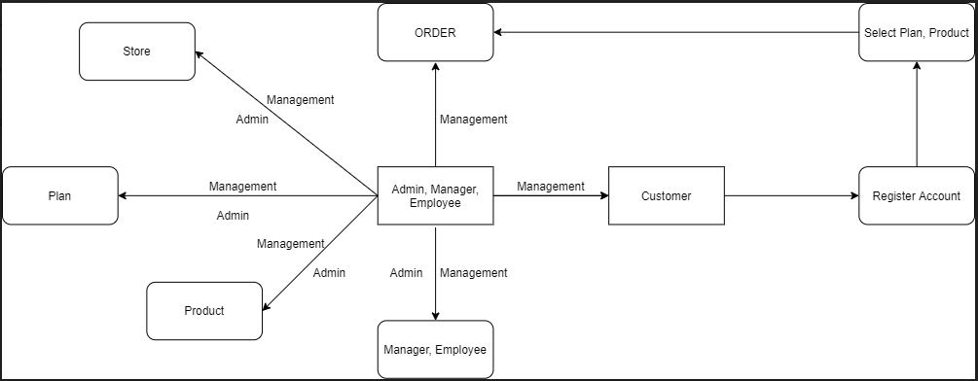

**DESIGN DATABASE**

## TABLES

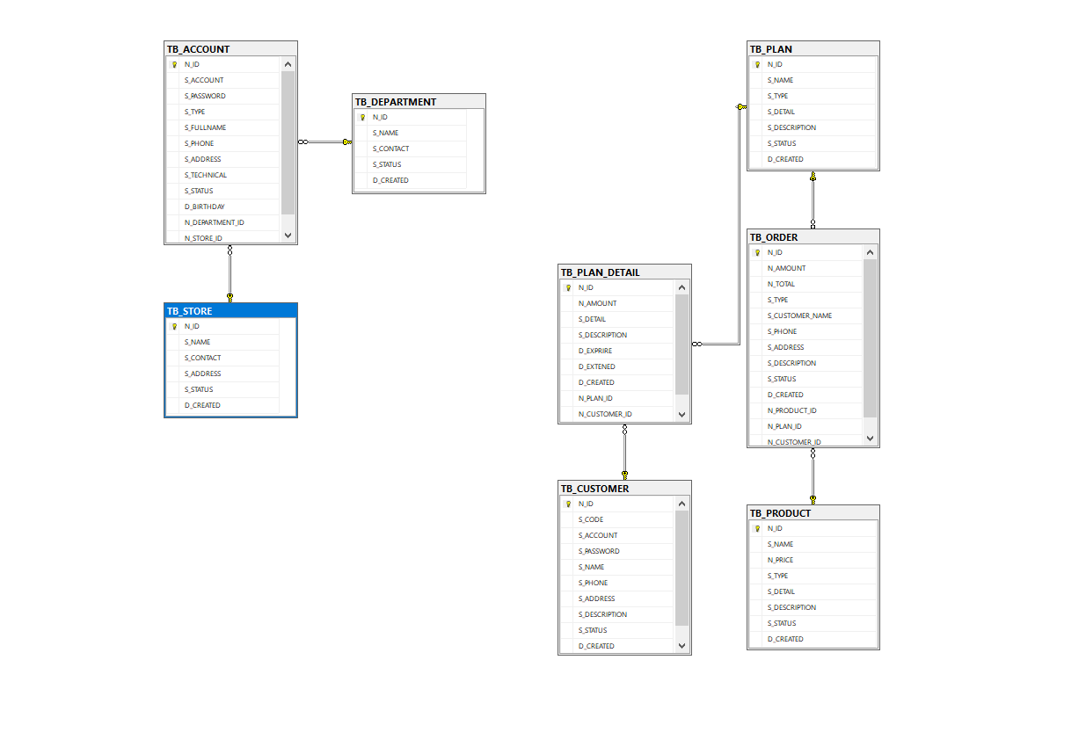

**INTERFACE AND FEATURES**

## Login

* All User can login and logout, If your account doesn’t exist, system will throw an alert wrong account

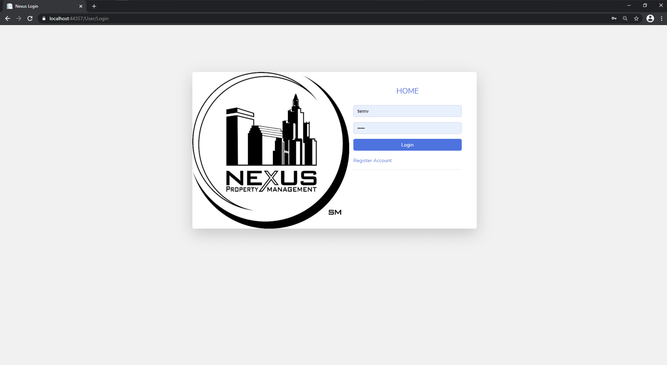

## Home

* You can visit to home page. If you login you will see your name.

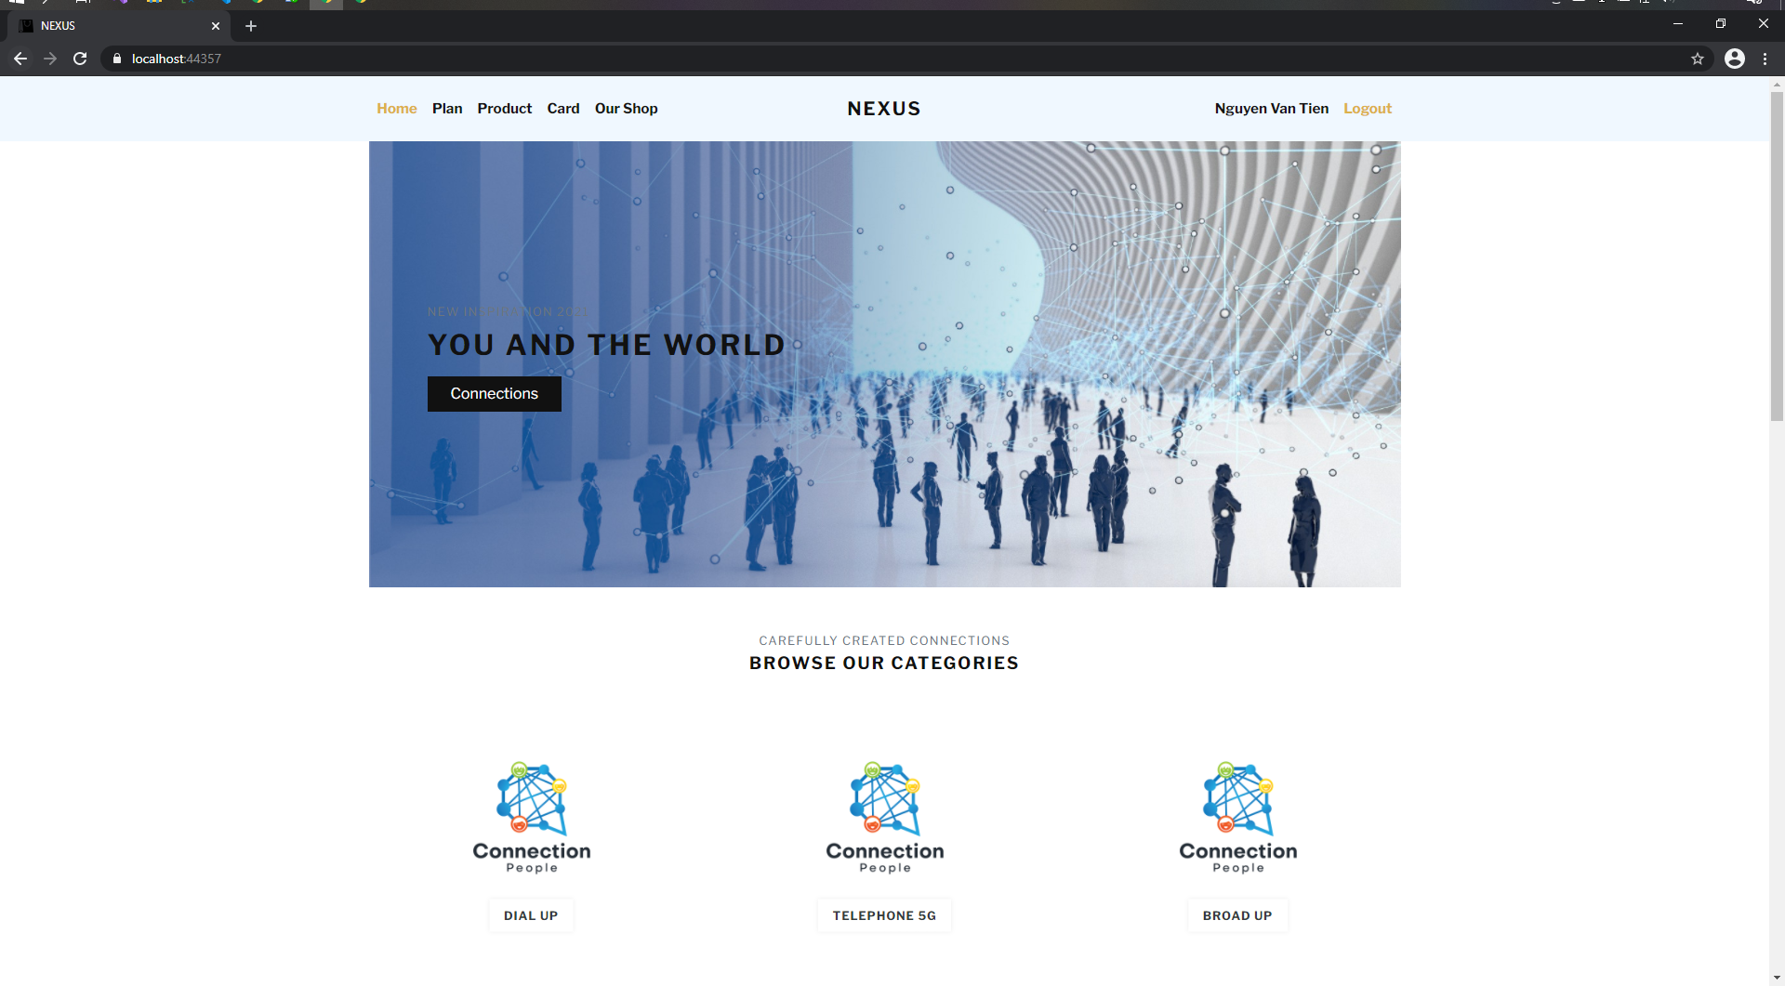

## List Plan

* When you click **Plan** in the tap menu, You wil see all Plan of Nexus

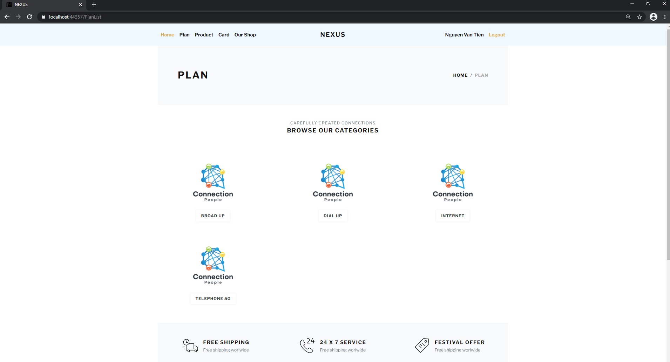

## List Product

* When you click **Product** in the tap menu, You wil see all Product of Nexus

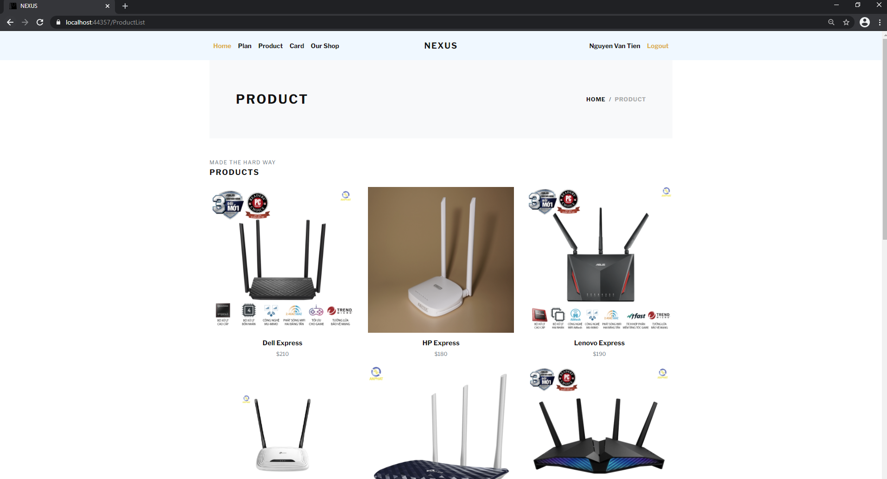

## Card

* If you click on Card and you are not logged, you will forward to login page. When you are logged into system, you will see your card

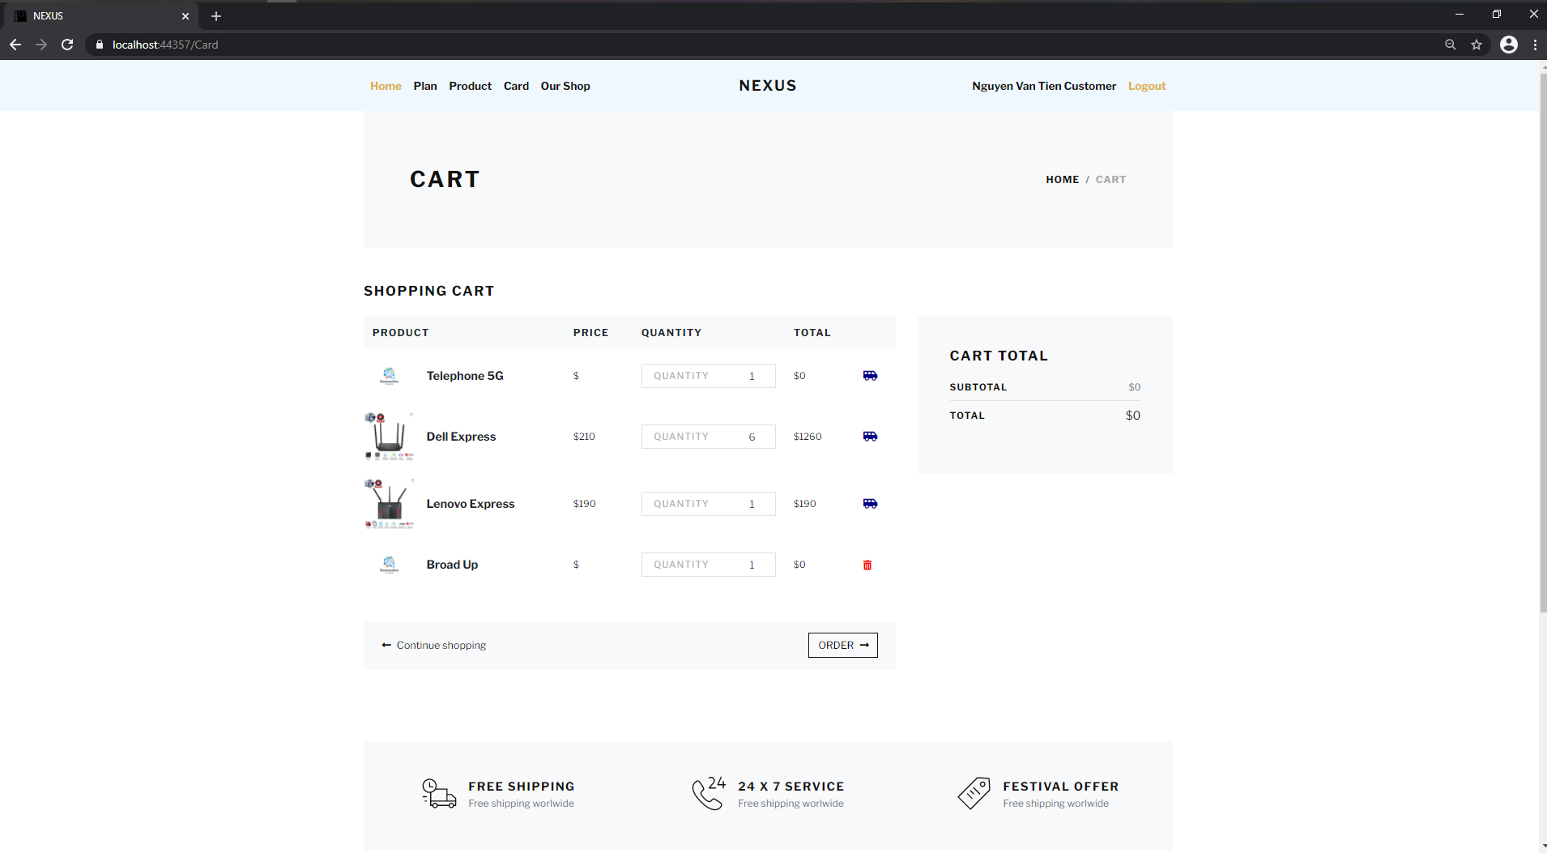

## Shop

* When you click on **Our Shop** in tap menu, you will see our shop. Include Address and contact

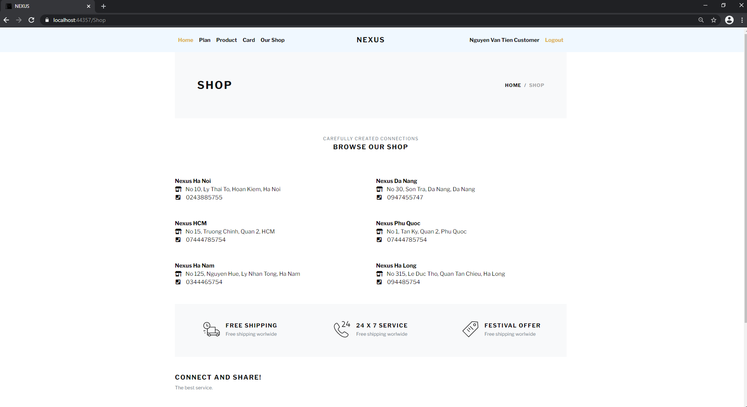

## Detail

* When you select a product or plan, you wil see detail of product

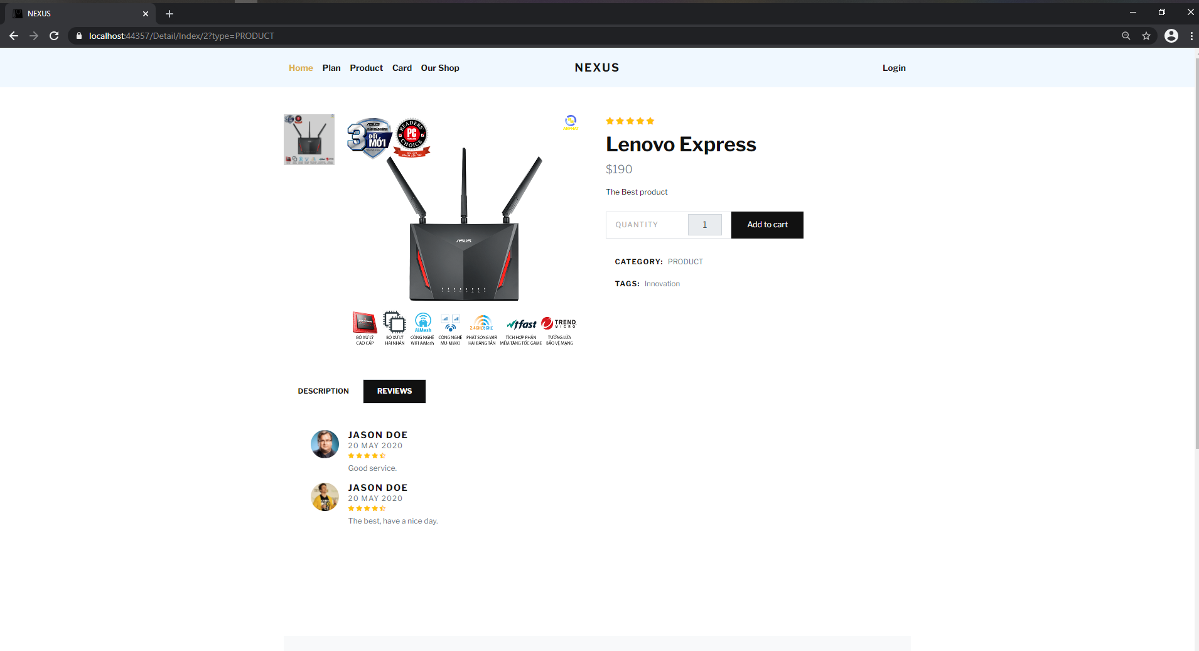

## Register Account

* If you doesn’t have an account. You can register when click on **Register Account** link in Login page. You can register an account

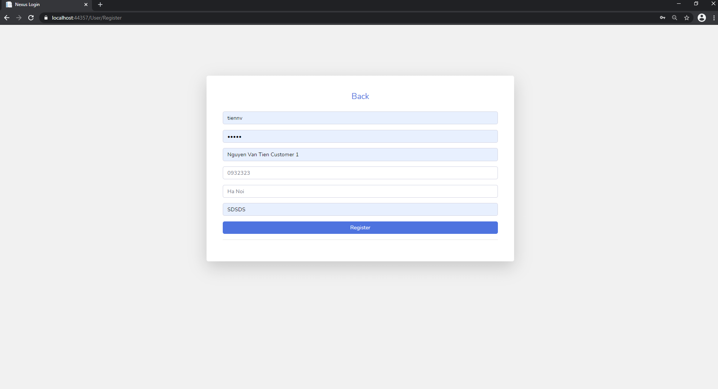

## Admin Login

* You can login into admin system with route Admin/Login

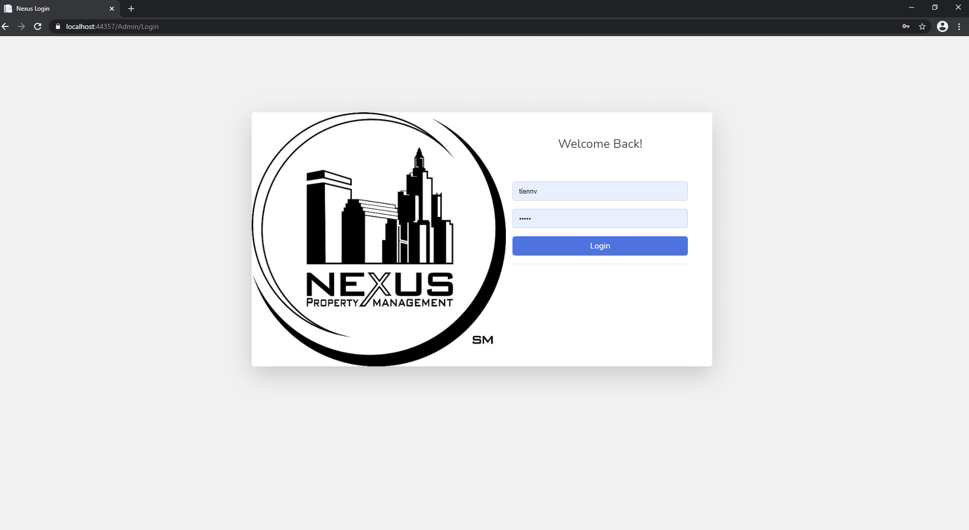

## Admin Department Management

* When you logged into system or when you click on DEPARTMENT on tap menu, you can see list department. You can add new, edit or inActive a department

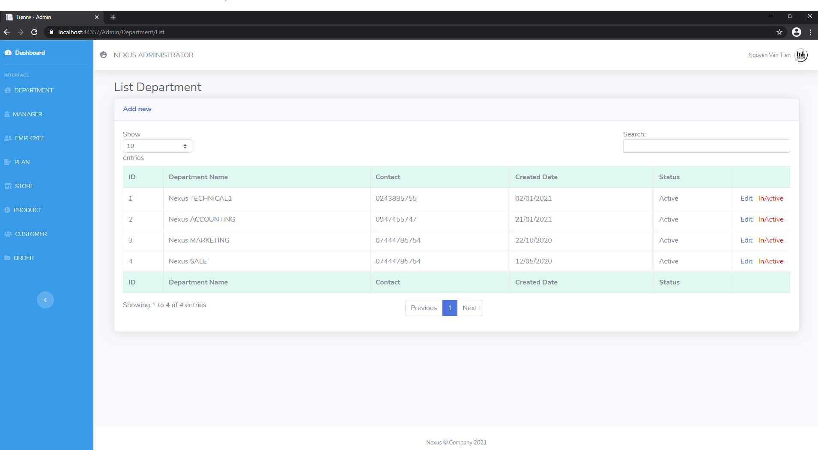

## Admin Manager Management

* When you click on MANAGER on tap menu, you can see list manager. You can add new, edit or inActive a manager

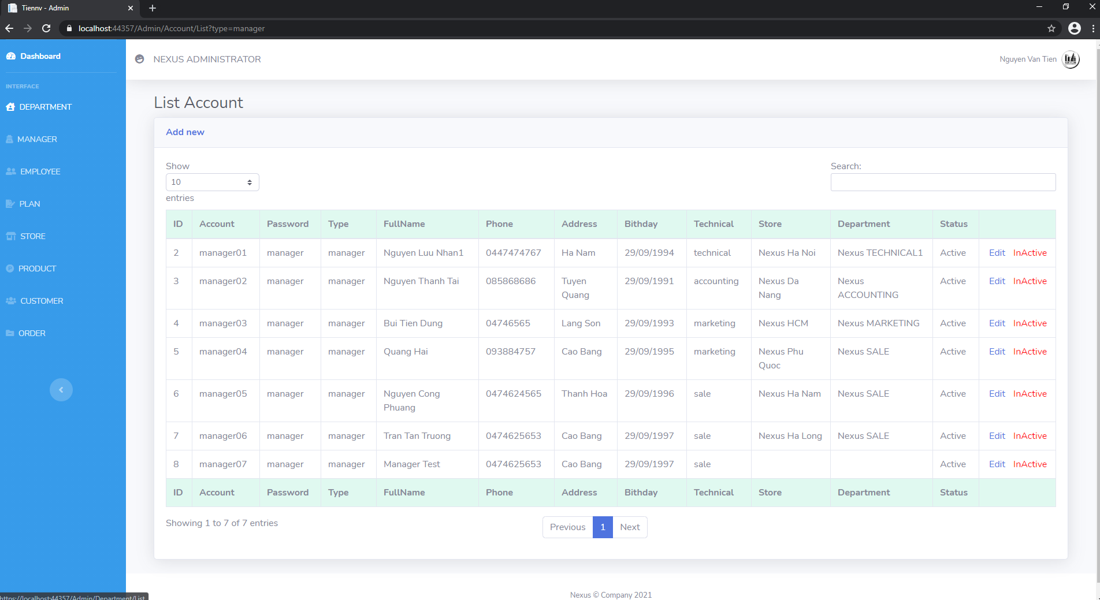

## Admin Employee Management

* When you click on EMPLOYEE on tap menu, you can see list employee. You can add new, edit or inActive an employee

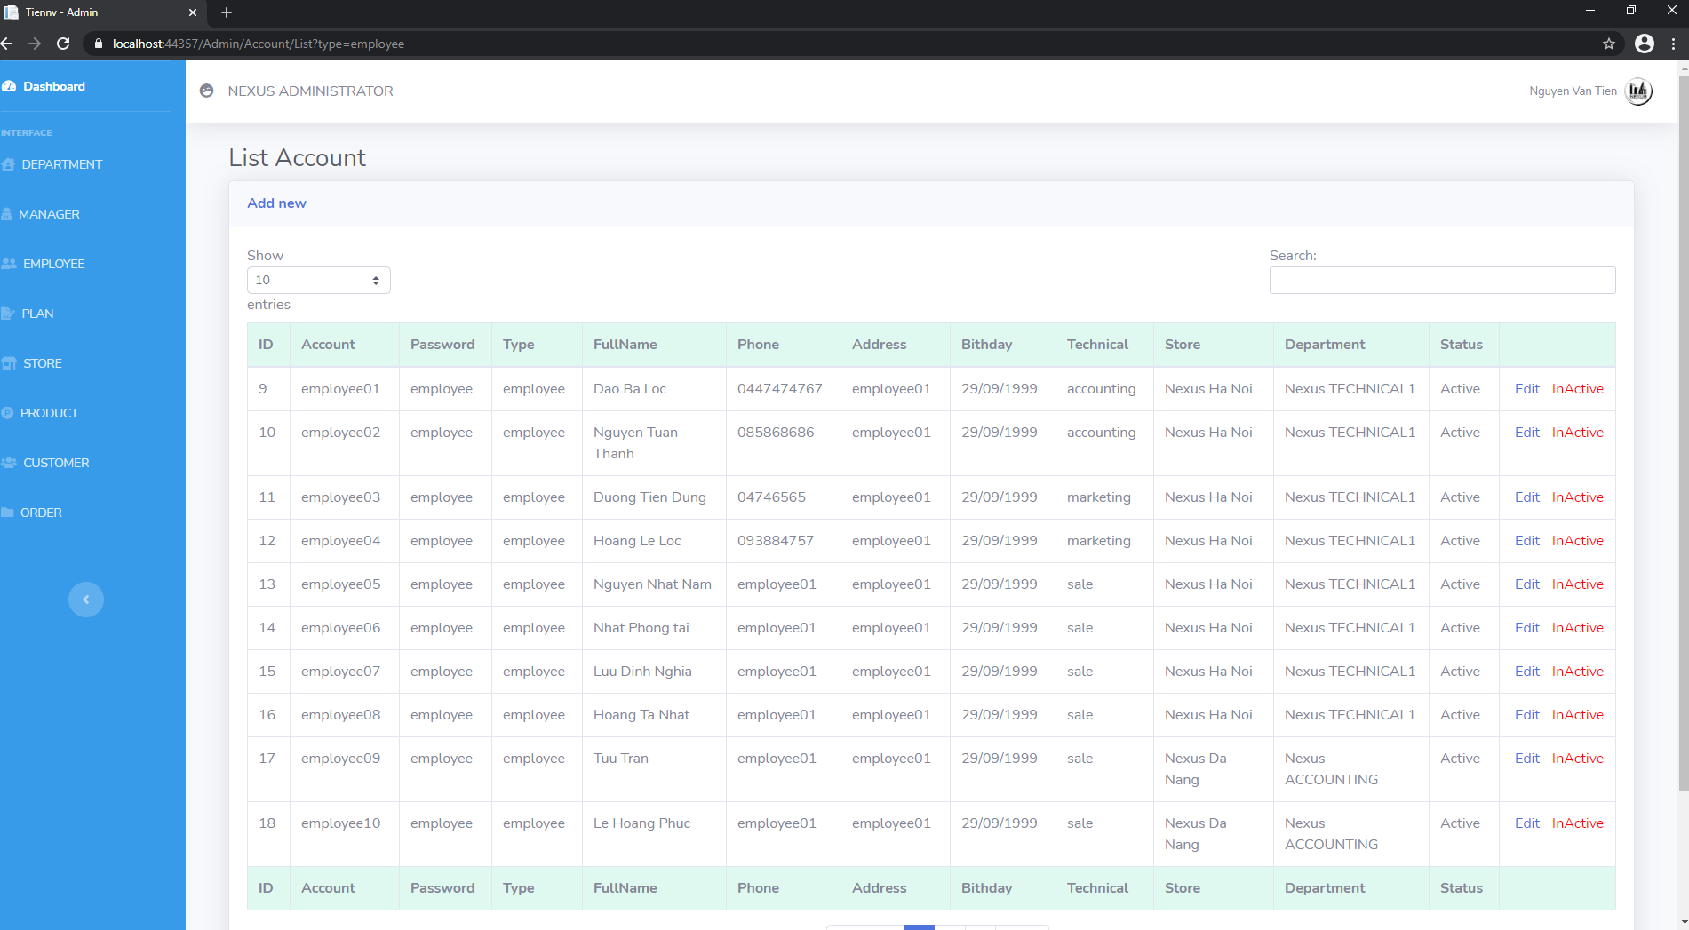

## Admin Plan Management

* When you click on PLAN on tap menu, you can see list plan. You can add new, edit or inActive a plan

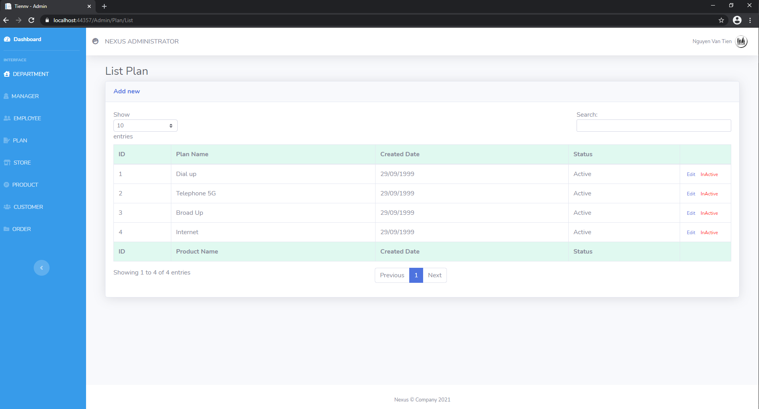

## Admin Store Management

* When you click on STORE on tap menu, you can see list store. You can add new, edit or inActive a store

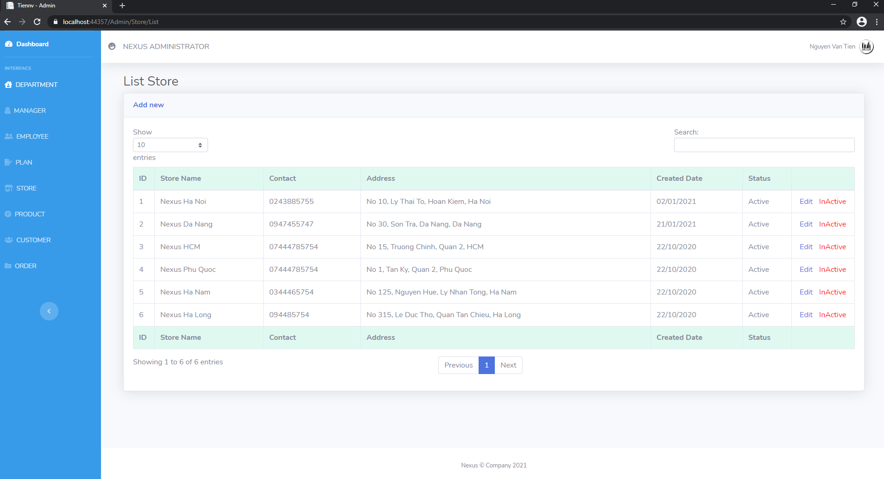

## Admin Product Management

* When you click on PRODUCT on tap menu, you can see list product. You can add new, edit or inActive a product

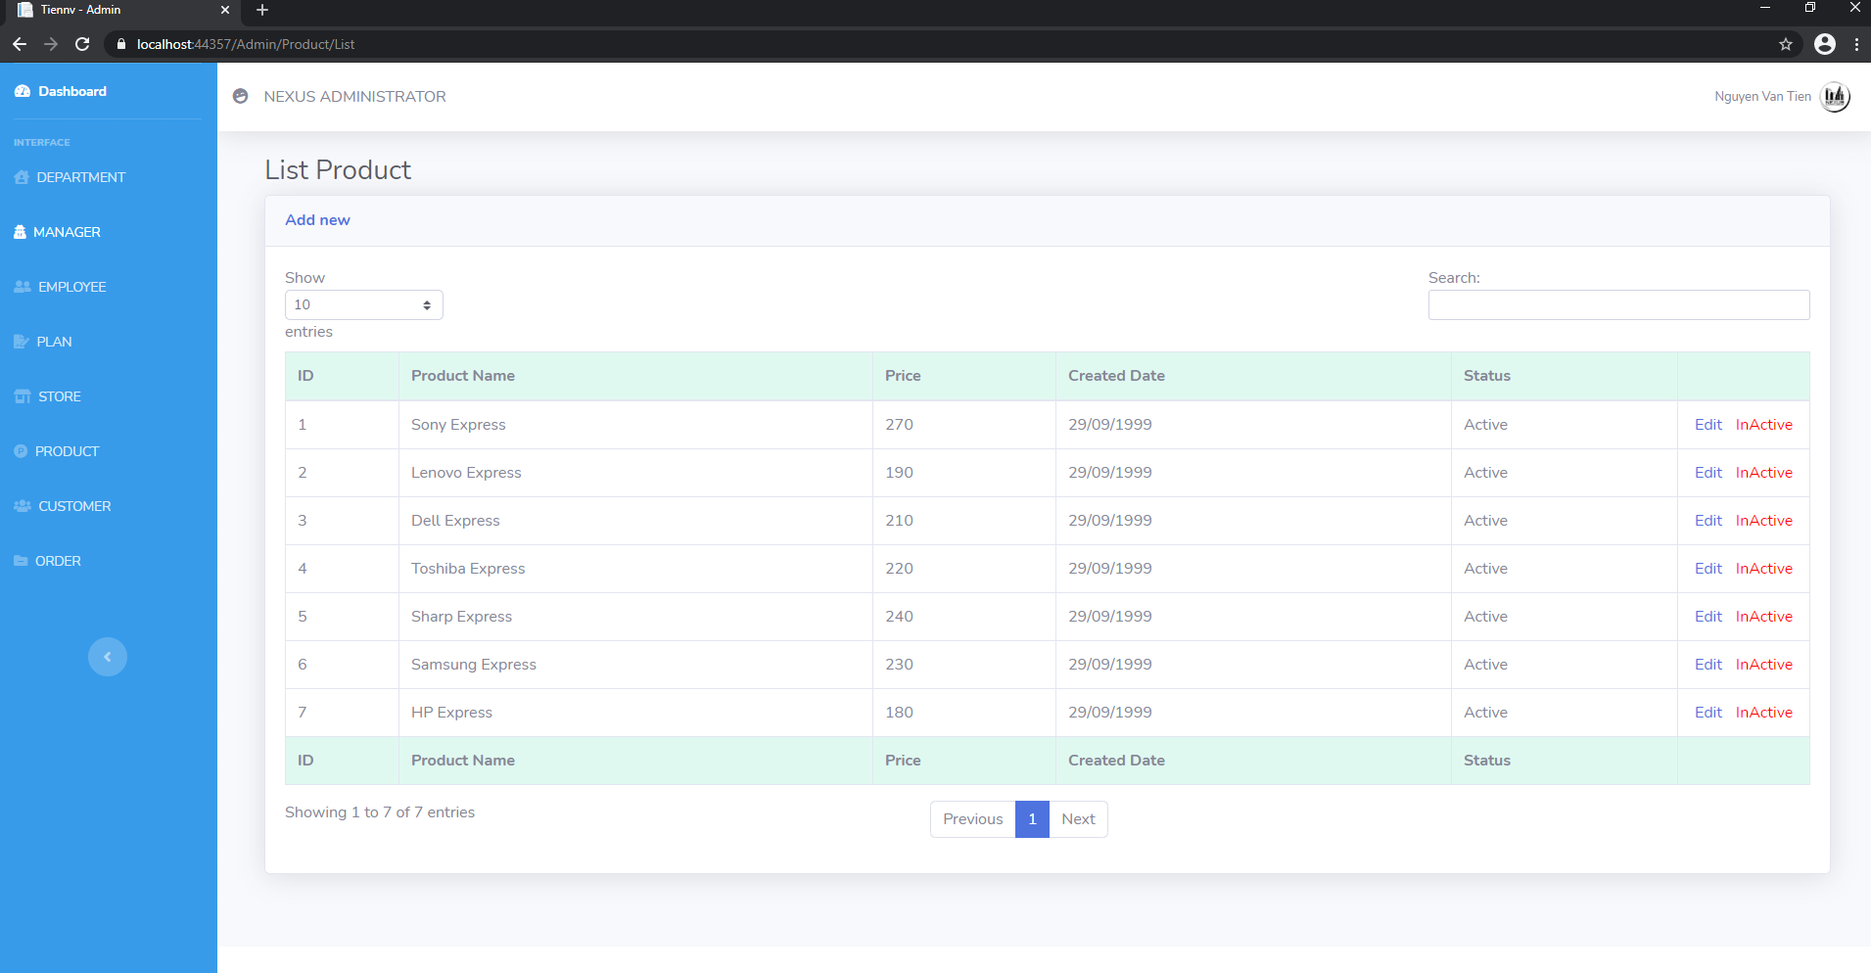

## Admin Customer Management

* When you click on CUSTOMER on tap menu, you can see list customer. You can add new, edit or inActive a customer

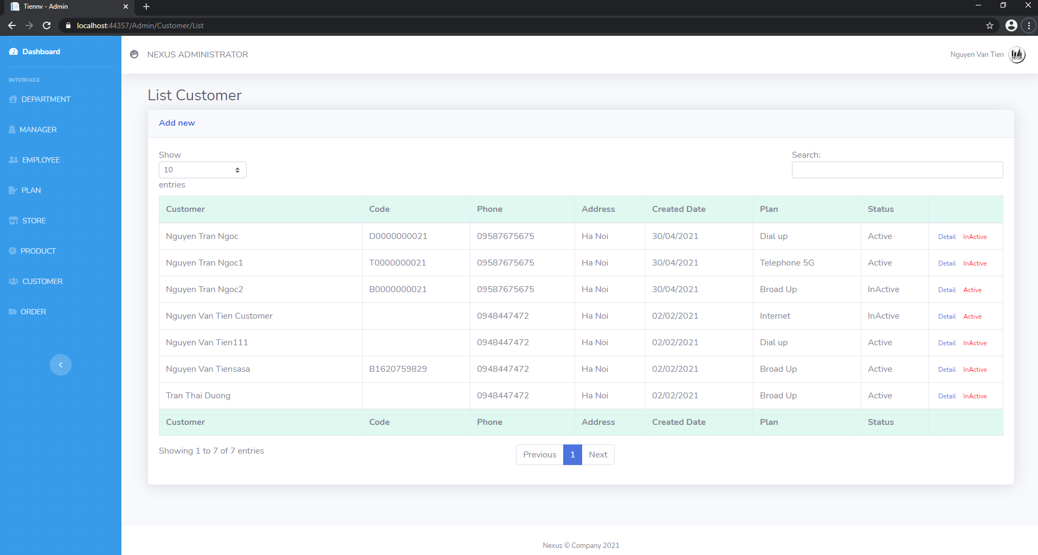

## Admin Order Management

* When you click on ORDER on tap menu, you can see list order. You can view a order when click on Detail

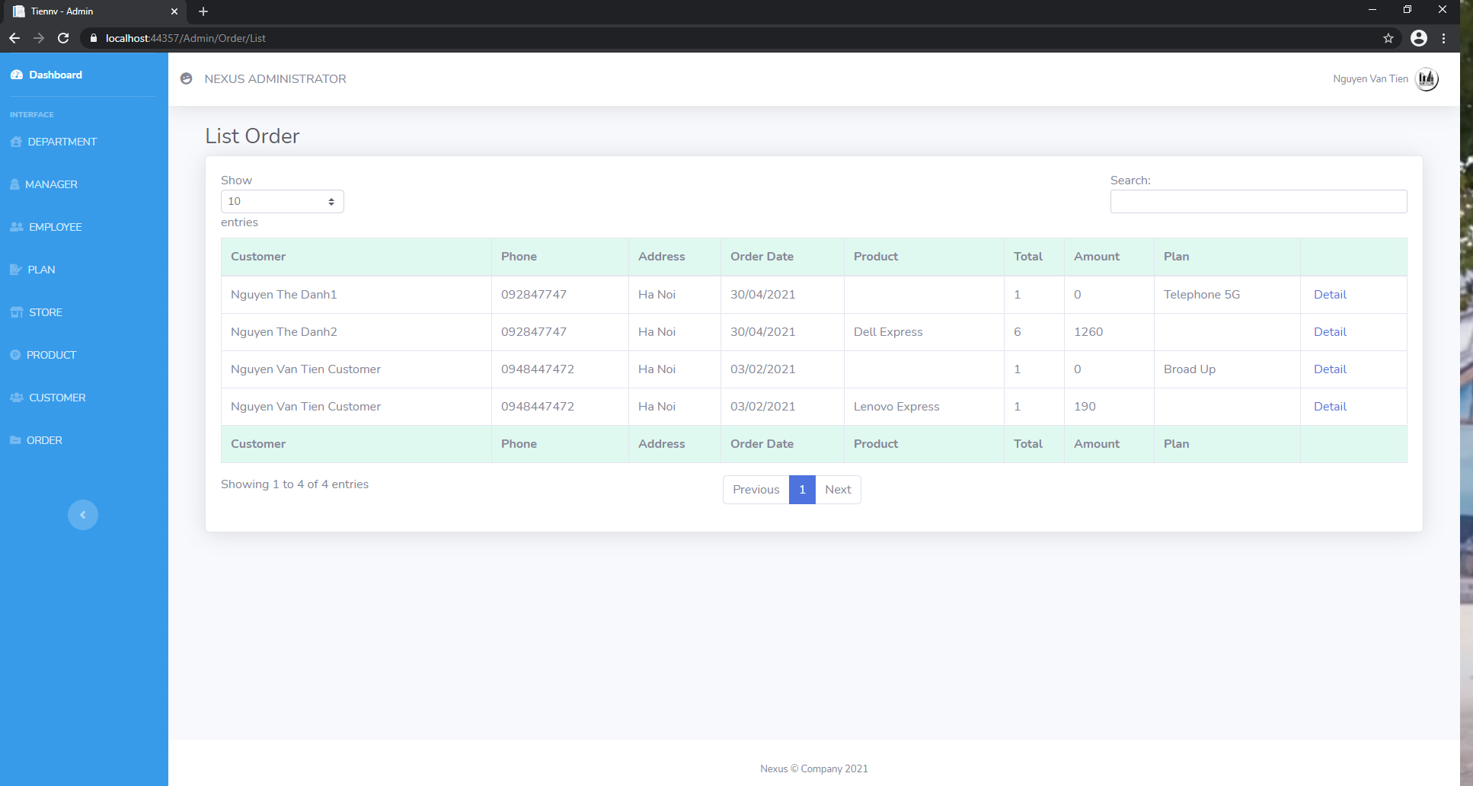

**SUMMARY**

## Results achieved

* Through the process of completing the project, I have drawn a lot of useful things for myself to serve the upcoming work:
  + How to analyze the system, design the database for a system and management website system,…
  + Learn how to use .NET framework to apply MVC model, combine with HTML, CSS, Javascript,... to develop a dynamic website.

## Development direction

* The website has now implemented the necessary commands and operations of a system, of course still has many limitations.
* The development direction of the website will move towards a fully functional website. Later times need additional functions such as :
  + Management User/Account
  + Management detail a system of a company
  + Make beautiful systme